MINI PROJECT:

Automatic door sensor:



Name : N.Praneetha.

TABLE OF CONTENTS:

|  |  |  |
| --- | --- | --- |
| SERIAL NO | CONTENT | PAGE NO |
| 1 | Introduction | 3 |
| 2 | Objective | 3 |
| 3 | Advantages | 3 |
| 4 | Requirements | 4 |
| 5 | Swot analysis | 4 |
| 6 | Design | 4,5 |
| 7 | Test plain and output | 5,6 |

* Introduction: Automatic entrance/exit door control is widely used in public places such as grocery stores, businesses, transportation stations, airports, and wholesale department stores to eliminate the need of manually opening and closing actions. Contemporary sensor-based automatic door control technologies include infrared, ultrasonic/radio, or other wireless sensing methods. The first can be OPEN ACCESS

Sensors 2013, 13 5924 further divided into active and passive approaches. The active process emits infrared signals from the controller and captures the reflected signals to determine if there is any object close to the door. This approach is accurate and capable of identifying the position and the speed of the object but its high cost has made it less popular. The passive approach detects the infrared signals radiated by people and is the most widely used for being simple, effective, and low cost. The ultrasonic/radio approach, on the other hand, emits ultrasonic or radio waves to scan the environment and analyzes the returned signals for door access contro.

* Objective: The aim of this research work is to design and construct a simple model of an automatic sliding door and the objectives is to develop a simple model that can be transformed into a bigger project and also to understand the concepts involved in how an automatic sliding door works and to fabricate a simple model to show how the system works within the expected timeframe and with the available resources.
* Advantages:
* Easier entrance and exit monitoring.
* Remote control.
* Easy entrance and exit for materials and supplies.
* Easy entrance for people with disabilities.
* Lesser maintenance and assorted costs.
* Requirements:
* High level requirements:
* One of the best thing about automatic doors is that it comes in an array of different styles ,shapes, colours,finishes and modern designs are aviable.
* Automatic doors grant you the option to open and close the door as well.
* This door system is maintaince high quality and easy to use and very safety.
* Low level requirement:
* Automatic doors are more expensive.
* Moreover in this case of to repair the doors, are also expensive as compared to traditional doors.
* Automatic doors are more difficult to clean as you need to polish and oil and internel parts.
* SWOT Analysis:
* STRENGTH: Can be used for sulphide ore and waste discrimination.

Can be used for identification of associated with place.

* WEAKNESS: Processing and handling is difficuilt.
* OPPORTUNITIES: Development are dynamic and advancing rapidly.

Most advanced technology.

Internet of things.

* THREATS: Sensor dis connection.

More power consumption

DESIGN: BLOCK DIAGRAM.

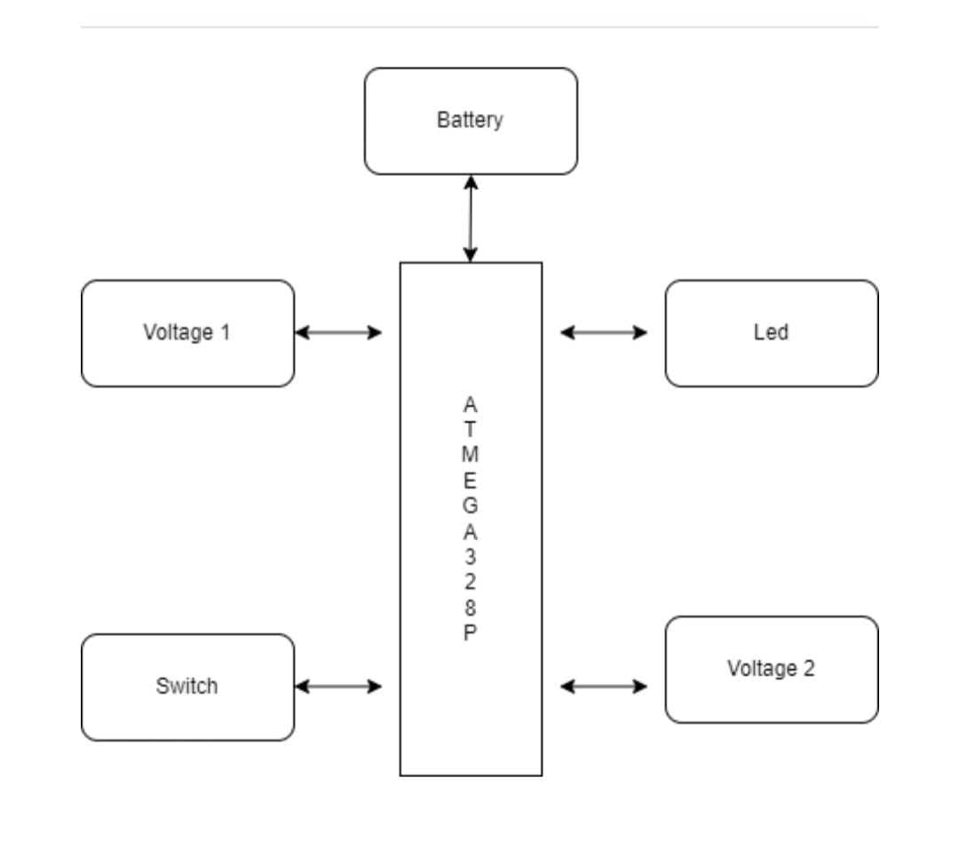

* DATA FLOW DIAGRAM.

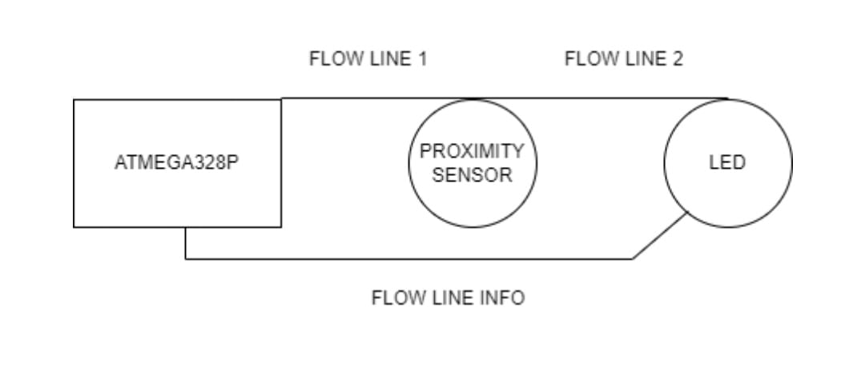

* TRANSMISSION DIAGRAM

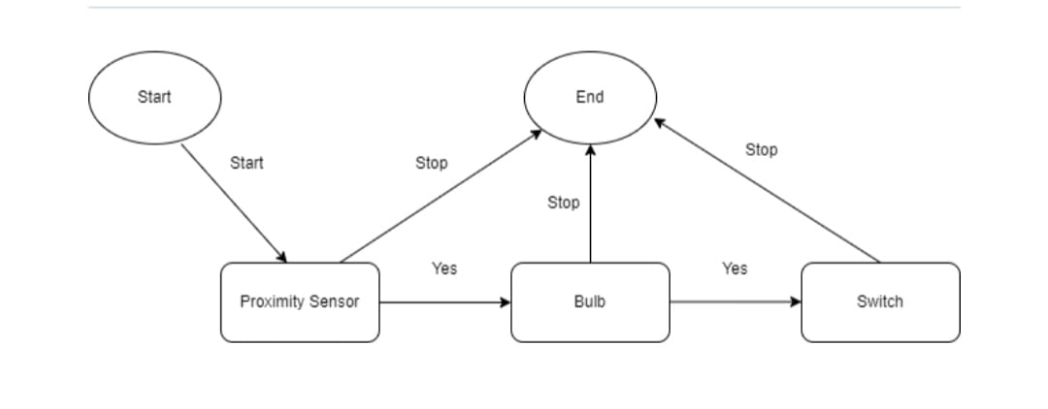

* TEST PLAIN OUTPUT:
* Schematic diagram of condition.

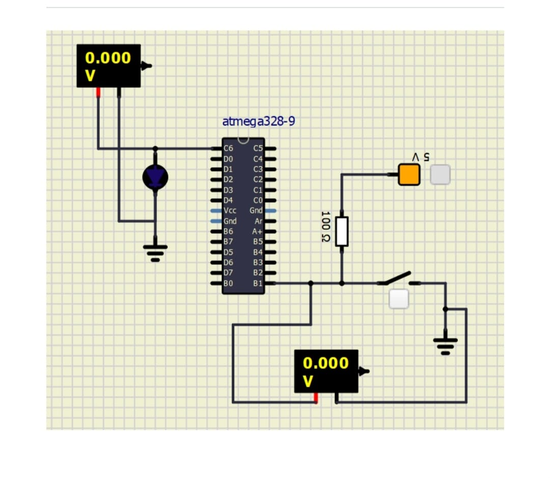

* Schematic diagram on codition.

